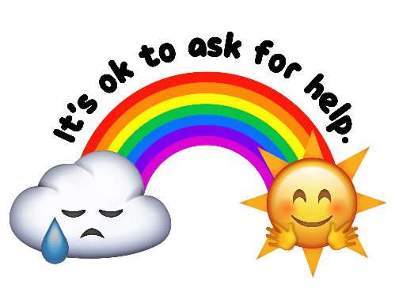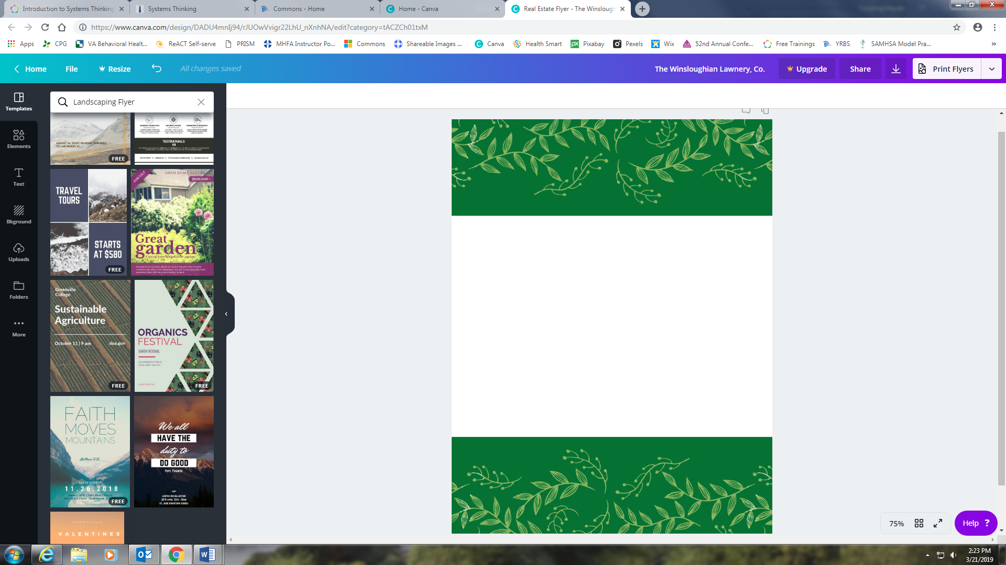

Start your weekend off the right way and come join the Arlington County Department of Human Services for a fun-filled evening to celebrate Mental Health Awareness Month! There will be a variety of FREE games and activities for all ages including life-size bowling, tug-of-war, yoga, and Zumba. The first 50 people to arrive will receive a free t-shirt. Everyone is welcome, so bring your family and friends. You won’t want to miss the fun!

For additional information, contact Linh Nghe at [lnghe@arlingtonva.us](mailto:lnghe@arlingtonva.us).

In the case of inclement weather, the event will take place at the Arlington County Department of Human Services Sequoia I at 2100 Washington Blvd., Arlington, VA 22204.



**Arlington Family Wellness Day**

Friday May 3, 2019, 4:30-7:30pm

Butler Holmes Park

101 S Barton St.

Arlington, VA 22204

