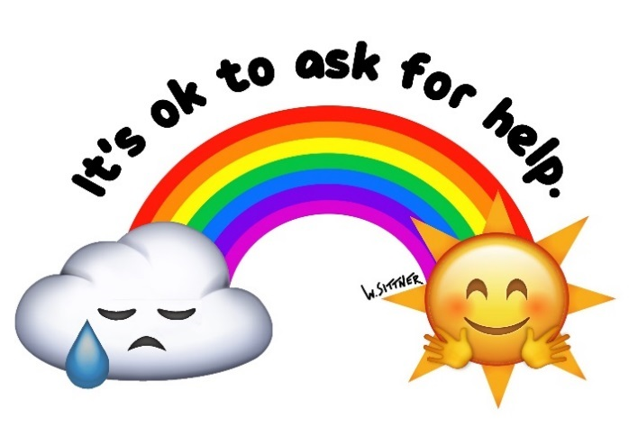

**Child & Family Services Division**

**Department of Human Services**

**Mental Health Awareness Month**

**MAY 2019**

May is Mental Health Awareness Month! Child & Family Services Division is focusing on promoting wellness and raising awareness in the community to combat the stigma of mental health.

**In the Schools:**

***Hosting informational tables for students during their lunch hours; Prevention programs held in schools.***

**Apr 29** Angst showing: Raising Awareness around anxiety, Yorktown HS, 6:30pm

**May 2** Thomas Jefferson Community Center,

5-7pm

**May 2** Strengthening Families Program, Gunston MS, 6-8pm

**May 3** Mythbusters, Thomas Jefferson 8:36-11:33 am

**May 8** Mythbusters, Gunston 10:50am-2:21pm

**May 9** Strengthening Families Program, Gunston MS, 6-8pm

**May 13** Swanson Middle School, 10:15am-1:00pm

**May 14** HB Woodlawn, 9:30-10:30am

**May 16** Strengthening Families Program, Gunston MS, 6-8pm

**May 20** Yorktown HS, 10:30-1:30am

**May 21** Mythbusters, Kenmore12:48-2:24pm

**May 22** Mythbusters, Swanson 8:41-10:41am

**May 23** Junior Class Assembly (N=400) presentation on sexual assault and substance use (in collaboration with PEACE), Yorktown HS, 1:30-3pm

**May 24** Mythbusters, Swanson 7:50-9:24am

**May 24** Senior Class Assembly (N=400) presentation on sexual assault and substance use (in collaboration with PEACE), Yorktown HS, 12:30-1:30pm

**In the Community:**

***Hosting informational tables, providing educational/prevention programs in various community locations.***

**April 24** Healthy Relationships Presentation, Kenmore Hispanic Mothers, 9-10:30am

**April 24** Darkness to Light Training

Sequoia Auditorium, 6:30-8:30p

**April 30** AHC Resource Fair, The Shell, 5-8p

**May 1** Fairlington Community Center, 10-12am

Walter Reed Community Center, 2-4pm

**May 2** Arlington Mill CC; Project Family Series – Building responsible kids, 5:30-7:00 pm

Our Relationship with our kids

**May 3** Community Wellness Day, Butler Holmes Park, 4:30-7:30pm

**May 6** Lock and Talk Presentation at Columbia Pike Library, 6:30pm

**May 6** Teen Narcan Training, Central library 5:00- 6:30pm

**May 9** Arlington Mill CC, Project Family Series, Building responsible kids, 5:30-7:00 pm

**May 15** Angst showing: Raising Awareness around anxiety, Central Library, 6:30pm

**May 16** Arlington Mill CC; Project Family Series, 5:30-7:00pm on Threats

**May 18** Truck Day, Central Library, 8:00-11:30am

**May 23** Arlington Mill CC, Project Family Series, 5:30-7:00pm on Structure

**May 28** Arlington Mill Community Center, 3-5pm

**May 29** College Bound Mythbusters, DHS 6-8pm

**May 29** DHS Behavioral Health Services presentation, Central Library, 5-8pm

**May 30** Arlington Mill CC; Project Family Series, 5:30-7:00pm on Expectations

**May 31** Westover Library, 10-12am

**June 6** Arlington Mill CC; Project Family Series, 5:30-7:00pm on Incentives

**June 13** Arlington Mill CC; Project Family Series, 5:30-7:00pm on Responding in the Moment

J**une 20** Arlington Mill CC; Project Family Series, 5:30-7:00pm on Consequences

**At Department of Human Services:**

***Hosting informational tables and educational programs in the Sequoia Complex of buildings:***

**May 3** T-Shirt picture day, 12N SEQ1

**May 17** SEQ 3 Lobby, 10-12am

**May 22** Teen Clinic, 3-5pm

**May 28** SEQ 1 Lobby, 10-12am

**National Prevention Week! #npw2019**

***Hosting informational tables on the below topics, at various schools, in coordination with SAMHSA’s Prevention Week.***

**May 13** Prescription and Opioid Drug Misuse

**May 14** Underage Drinking and Alcohol Misuse

**May 15** Illicit Drug Use and Youth Marijuana Use

**May 16** Youth Tobacco Use

(Including e-cigarettes and vaping)

**May 17** Suicide Prevention

Social Media Messaging throughout the month: @apcyf and @Arlington

#StandUpToStigma | #MentalHealthMonth

Strengthen, Protect, Empower